A000-Eur-Bulgaria-Stara Zagora-Thrace-Mask-Male-Ceramic-Neolithic-5500 BCE

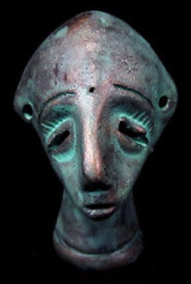

Fig. 1. Eur-Bulgaria-Stara Zagora-Thrace-Mask-Male-Ceramic-Neolithic-5500 BCE

**Case no.: 3**

**Accession Number:** A000

**Formal Label:** Eur-Bulgaria-Stara Zagora-Thrace-Mask-Male-Ceramic-Neolithic-5500 BCE

**Display Description:**

A hollow ceramic with holes on either side at the level of the ears suggesting that earrings were placed there. Images of anthropomorphic masks such as this one may have been created for the kuker festival when strange, masked creatures were invoked to bless a fruitful harvest for the New Year. These hollow ceramic masks appear as though they were miniatures for such festivals.

**LC Classification:** DR98 S83

**Date or Time Horizon:** 6th Millennium BCE-Neolithic

**Geographical Area:** Stara Zagora, Bulgaria

**Map:**

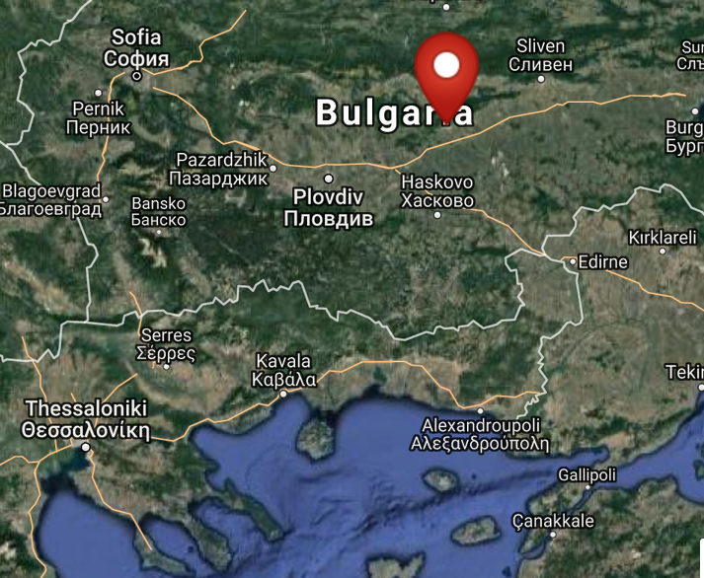

Fig. 2. Map of location of Stara Zagora, Bulgaria. From <http://latitude.to/lat/42.42604/lng/25.63356>

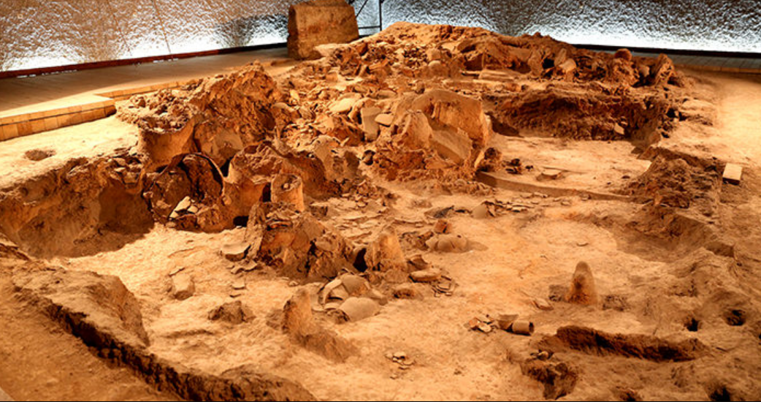

Fig. 3. Neolithic House, Stara Zagora regional Historical Museum, Bulgaria. http://www.getmetravelled.com/wp-content/uploads/2015/08/Neolithic-Dwellings-Museum_Stara_Zagora_Bulgaria.jpg

**GPS coordinates:** 42º25'33.74" N 25º38'0.81" E

**Cultural Affiliation:** 6th Millennium BCE-Neolithic

**Medium:** Original, ceramic; replica is made of a ceramic material and painted with special varnish and paint.

**Dimensions:** H 50 mm, W 33 mm

**Weight: 34 g**

**Condition: ceramic replica**

**Provenance:** original, Stara Zagora regional Historical Museum

**Discussion:**

The original wasfound in the ruins of a Neolithic settlement in the region of Stara Zagora, Bulgaria the Original is on display in the Archaeological Museum in Stara Zagora.

**References:**

Fol, V. 1997. “The kouker without mask. The masquerade feasts in Southern Europe. Orpheus,” *Journal of Indo-European and Thracian Studies*, 7, pp. 83-99.

Gaul, James Harvey. [1948. *The Neolithic period in Bulgaria: early food-producing cultures of Eastern Europe*](http://www.worldcat.org/title/neolithic-period-in-bulgaria-early-food-producing-cultures-of-eastern-europe/oclc/1001170812&referer=brief_results)*.*  Cambridge (Mass.): Peabody Museum.

[Krauß](http://www.worldcat.org/search?q=au%3AKrau%C3%9F%2C+Raiko.&qt=hot_author), Raiko; [Nedko Elenski](http://www.worldcat.org/search?q=au%3AElenski%2C+Nedko.&qt=hot_author" \o "Search for more by this author); [Bernhard Weninger](http://www.worldcat.org/search?q=au%3AWeninger%2C+Bernhard.&qt=hot_author); [Lee Clare](http://www.worldcat.org/search?q=au%3AClare%2C+Lee.&qt=hot_author); [Canan Çakirlar](http://www.worldcat.org/search?q=au%3AC%CC%A7akirlar%2C+Canan.&qt=hot_author" \o "Search for more by this author); [Petǎr Zidarov](http://www.worldcat.org/search?q=au%3AZidarov%2C+Peta%CC%8Cr.&qt=hot_author" \o "Search for more by this author). 2014. “Beginnings of the Neolithic in Southeast Europe: the early Neolithic sequence and absolute dates from Džuljunica-Smǎrdeš (Bulgaria),” *Documenta Praehistorica. Poročilo o raziskovanju paleolitika, neolitika in eneolitika v Sloveniji. Neolitske študije = Neolithic studies*, 41:51-77.

Perničeva, L. 2004. Anthropozoomorphe Figurinen aus dem späten neolithikum in Südwestbulgarien. In V. Nikolov & K. Băčvarov, eds., Von Domica bis Drama. Gedenkschrift für Jan Lichardus. (pp. 59–67). Sofia.

Todorova, Khenrieta. 1978. *The Eneolithic period in Bulgaria in the fifth millennium B.C*. Oxford: British Archaeological Reports.